Activity: Visual Design Critique Report
XDA-Reviews
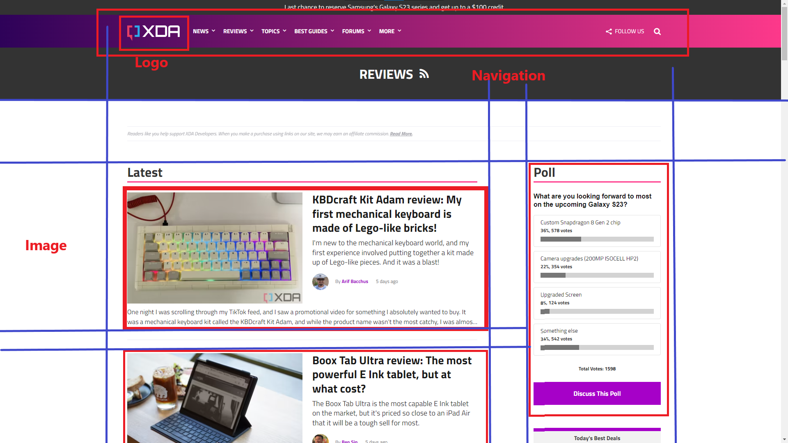
Part 1: Grid and Alignment
- Identify the columns, gutters, and show where text is horizontally aligned.
  - Text is Left aligned
- Which elements cut across more than one column?
  - Top navigation and PageTitle bar
- Where is the grid broken?
  - Top and right
- What are the different columns or sections used for?
  - Middle is where the reviews articles with image is shown
  - Right column is a poll widget
  - Top section is where the navigation and logo is located
- Where and why is white space used?
  - both left and right side of the page, right below the page title and also in between each review post

Part 2: Typeface and Emphasis
- Identify where and why the web site uses serif and sans serif fonts
  - Only used sans serif fonts
- Is font size used effectively? Where and how?
  - Yes, Titles and Review title are in bold large font, also poll question as well.
  - review subtitle was medium boiled font and then for text body was regular size
- Critique the use of font weight for importance or emphasis
  - The large bold font was easy to read and attention catching and made it easy to understand the page sections
- How is color used? How many different colors are used?
  - Simple use of color, bright purple for buttons, pink-red for section break, white for navi links and title, and black for text & gray for poll percent bar
Part 3: Overall Critique and Improvement
Comment on the effectiveness of the visual design.
- Very Effective, using a single column for reviews makes it simple to read and scroll through while looking for an article to read.
How would you improve the visual design?
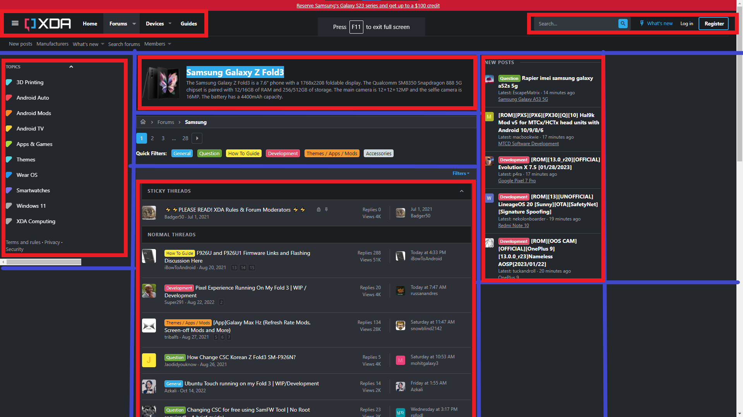
XDA Forums - Samsung Galaxy Z Fold3 Device Page

Part 1: Grid and Alignment
- Identify the columns, gutters, and show where text is horizontally aligned
  - Text is left aligned
- Which elements cut across more than one column?
  - Top Navigation
- Where is the grid broken?
  - Middle column area
- What are the different columns or sections used for?
  - Left is Topics, Center for forum threads, right is new posts
- Where and why is white space used?
  - Mostly in between each forum posts
Part 2: Typeface and Emphasis
- Identify where and why the web site uses serif and sans serif fonts
  - sans serif only
- Is font size used effectively? Where and how?
  - Post titles are a bit bigger than data font size and is in bold
- Critique the use of font weight for importance or emphasis
  - Each post title is in bold
- How is color used? How many different colors are used?
  - Color is mostly white title fonts, gray text and blue for links
  - Also Post categories are colored highlights to help understand what category is this post on (General Question How To Guide Development Themes / Apps / Mods Accessories)
Part 3: Overall Critique and Improvement
Comment on the effectiveness of the visual design.
- Color highlights for the post are very effective and helpful
How would you improve the visual design?

